Data-Exploration-Excel-Worksheet
This project focuses on organizing, analysing, and extracting insights from a product dataset. Using fundamental Excel functions, the workflow transforms raw product metrics such as pricing, Price range, and product count into a structured summary.
Dataset Description:
Product ID, Product Name, Brand Name, Quantity, Category, Price
Column Description:
Column Name | Description
Product ID | ID Numbers
Product Name | Name of the Product
Brand Name | Brand name of Product
Price | Price of the Product
Quantity | No of Quantity by Product
Category | Category based on the Product
Data Exploration:
We have done the data exploration using excel formula’s.
Basic Data Exploration
1. Sum, Count, and Average
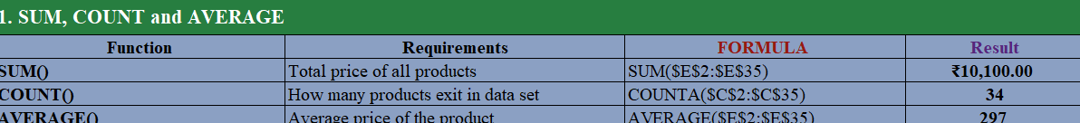
2. Minimum and Maximum Values
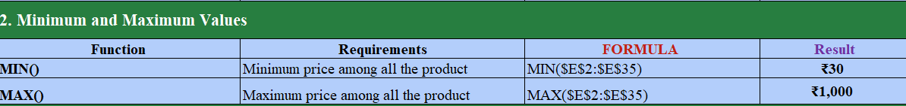
3. Logical Function – IF
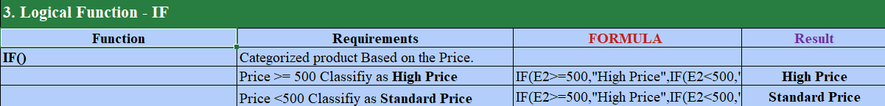
4. Conditional Functions – SUMIF and COUNTIF
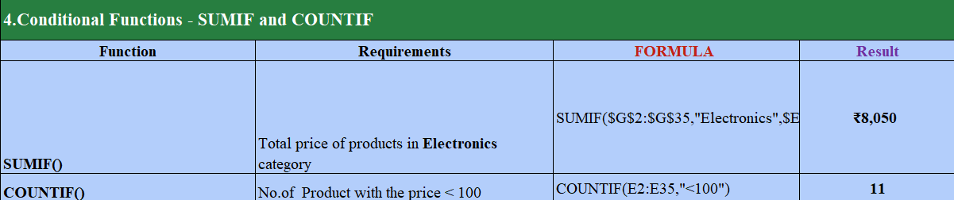
5. Text Formatting – LEFT, RIGHT, MID
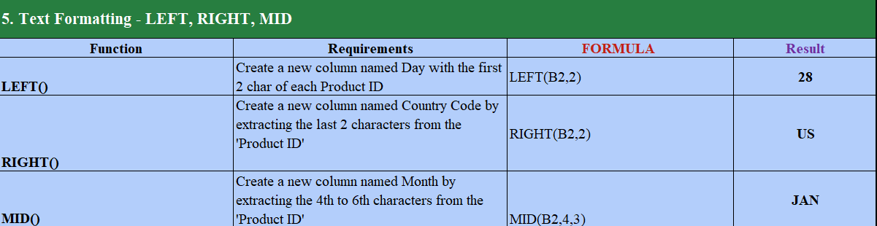
CONCULSION:
Using core Excel functions, the raw dataset was transformed into a structured, actionable summary of inventory health and performance, successfully meeting all project goals.
